**1.Modelo RF5_Indeg Cont1Repar2DiqCINT X All var**.

***Instrucciones modelo***: **test size = 0.23 ; rd_state = 14**

***Variables indep select to fit***:

variables = [  'id',  'Indeg_RedeRisk_Cen',    'Indeg_RedeConfianc',  'PC1_Distance_Pro',

    'Degree_RedeTotFamil', '5_VarExp_Atri_Idade',    '9_VarExp_Atri_IndMelhorTecnDiqCint',

    'Area_bolanha',  'OutDeg_IntimAmigos_',  'OutDeg_RedeRisk_Cen'  ]

***Model performance (scores):***

Mean Squared Error: 1.7667

R^2 Score: 0.4076 (In Excel: R2 = 0.5572 ; Y = 0.7101 X + 0.9918)

**Model tot:**

Mean Squared Error (MSE): 1.4419

Root Mean Squared Error (RMSE): 1.2008

Mean Absolute Error (MAE): 0.7442

R^2 Score: 0.8137

Pearson Correlation: 0.9165

***Interactions***:

| **Interacción** | **Importancia** | **Dirección** |
| --- | --- | --- |
| 0 | (Degree_RedeTotFamil, 9_VarExp_Atri_IndMelhorT... | 1.020570 | 0.148582 |
| 1 | (Indeg_RedeConfianc, Degree_RedeTotFamil) | 0.767000 | 0.142330 |
| 2 | (Indeg_RedeConfianc, 9_VarExp_Atri_IndMelhorTe... | 0.669185 | 0.124364 |
| 3 | (Indeg_RedeRisk_Cen, Degree_RedeTotFamil) | 0.662530 | 0.117228 |
| 4 | (Degree_RedeTotFamil, Area_bolanha) | 0.615505 | 0.109124 |
| 5 | (Degree_RedeTotFamil, 5_VarExp_Atri_Idade) | 0.600854 | 0.109816 |
| 6 | (Indeg_RedeConfianc, OutDeg_IntimAmigos_) | 0.596258 | 0.141729 |
| 7 | (Indeg_RedeConfianc, OutDeg_RedeRisk_Cen) | 0.595678 | 0.140417 |
| 8 | (PC1_Distance_Pro, 9_VarExp_Atri_IndMelhorTecn... | 0.593053 | -0.000237 |
| 9 | (Indeg_RedeConfianc, 5_VarExp_Atri_Idade) | 0.591579 | 0.139201 |

***Key results****:*

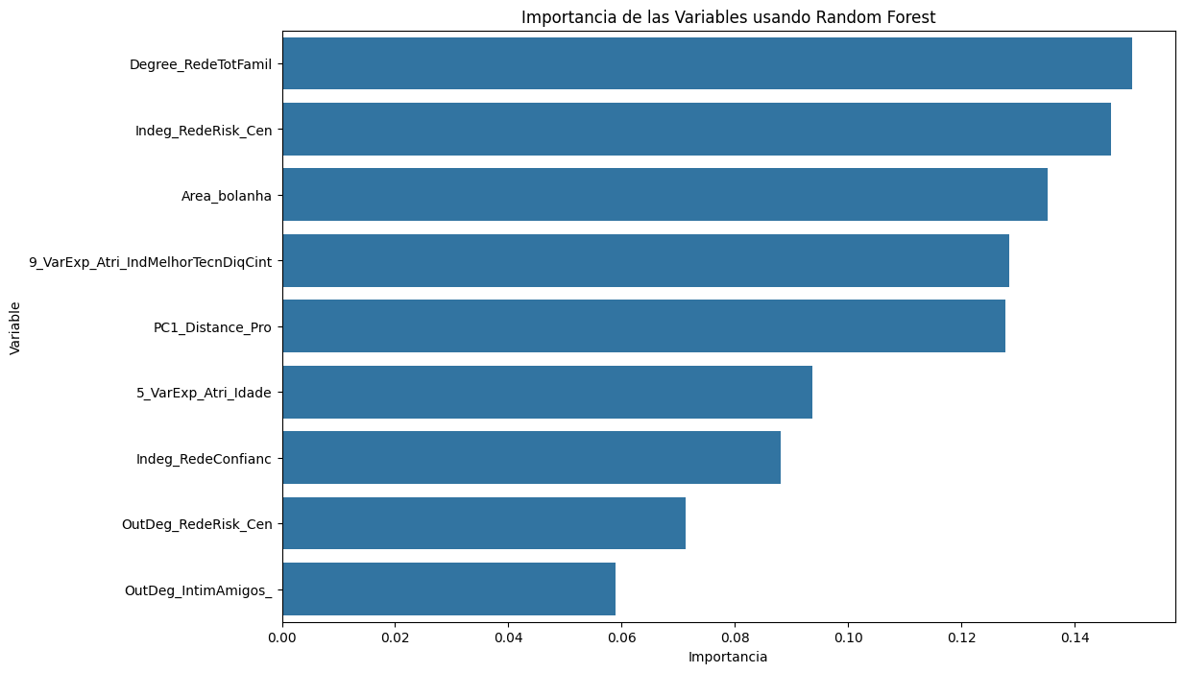

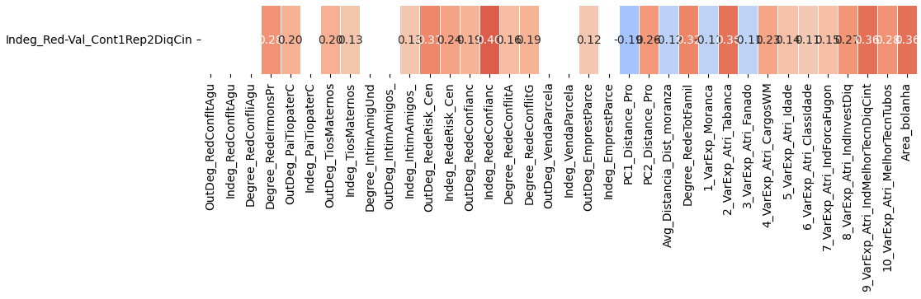

**2.Modelo RF5_Outdeg Cont1Repar2DiqCINT X All var**.

***Instrucciones modelo***: **test size = 0. ; rd_state =**

***Variables indep select to fit***:

variables = [  'id',    'Indeg_IntimAmigos_',    'Indeg_RedeConfianc',    '1_VarExp_Moranca',

    '9_VarExp_Atri_IndMelhorTecnDiqCint', '10_VarExp_Atri_MelhorTecnTubos',     'Area_bolanha',

    'OutDeg_RedeRisk_Cen']

***Model performance (scores):***

Mean Squared Error: 2.8333

R^2 Score: 0.7109 (In Excel: R2 = 0.7182 ; y = 0.7857 X + 0.5286)

**Model tot:**

Mean Squared Error (MSE): 1.1163

Root Mean Squared Error (RMSE): 1.0565

Mean Absolute Error (MAE): 0.5581

R^2 Score: 0.8726

Pearson Correlation: 0.9361

***Interactions***:

| **Interacción** | **Importancia** | **Dirección** |
| --- | --- | --- |
| 0 | (9_VarExp_Atri_IndMelhorTecnDiqCint, OutDeg_Re... | 1.685273 | 0.265761 |
| 1 | (9_VarExp_Atri_IndMelhorTecnDiqCint, Area_bola... | 1.644916 | 0.275280 |
| 2 | (Indeg_RedeConfianc, 9_VarExp_Atri_IndMelhorTe... | 1.621241 | 0.429284 |
| 3 | (9_VarExp_Atri_IndMelhorTecnDiqCint, 10_VarExp... | 1.581785 | 0.269271 |
| 4 | (Indeg_IntimAmigos_, 9_VarExp_Atri_IndMelhorTe... | 1.499611 | 0.030872 |
| 5 | (1_VarExp_Moranca, 9_VarExp_Atri_IndMelhorTecn... | 1.460998 | -0.019322 |
| 6 | (Indeg_RedeConfianc, OutDeg_RedeRisk_Cen) | 1.371050 | 0.464437 |
| 7 | (Indeg_RedeConfianc, Area_bolanha) | 1.330256 | 0.469639 |
| 8 | (Indeg_RedeConfianc, 1_VarExp_Moranca) | 1.304470 | 0.459978 |
| 9 | (Indeg_IntimAmigos_, Indeg_RedeConfianc) | 1.270457 | 0.040526 |

***Key results****:*



